Christopher WIlliams

May 1, 2018

Assignment 2 Write-Up

CTA Train App

The software design of your app, including diagrams of the key components (classes)

and their relations.

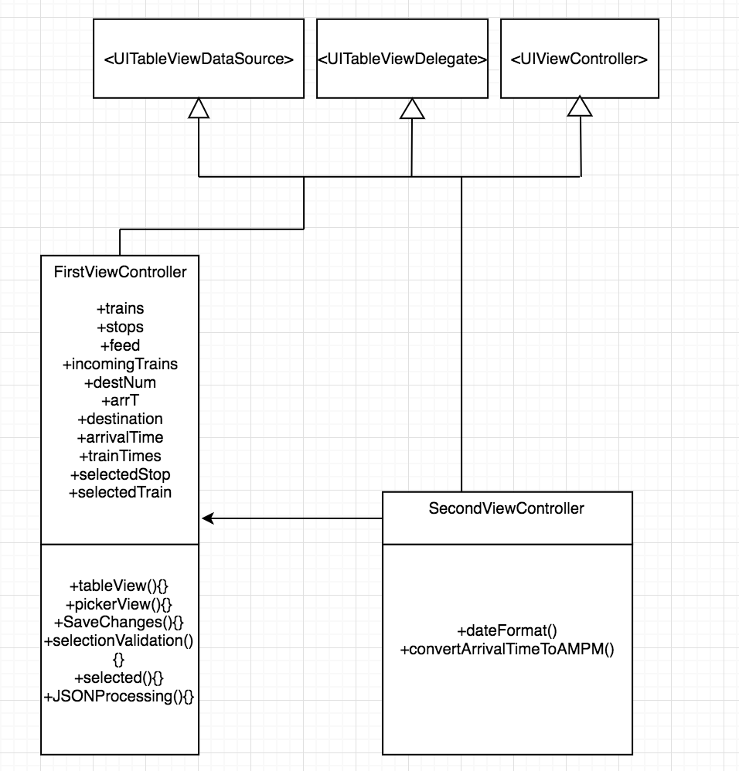

The class first view controller controls the first view. It loads the data for the pickers, saves the changes made when the user selects save changes. It validates correct selections, and it does JSON processing which checks for errors and makes sure the information being received is correct.

The second view controller loads a picker view with all the train times that are coming. It saves the changes that are made. Converts the times from JSON from 24 hour time to 12 hour time.

Both classes uses the global variables trains, stops, feed, incomingTrains, destNum, arrT, destination, arrivalTIme, trainTImes, selectedStop, and selectedTrain.

What error conditions and anomalies during the communication and in the data

content that you have considered in the design and implementation of your app? What

measures did you take to allow your app to continue to function in the presence of

these conditions?

The error conditions in my application are based on bad input. If the user selected the line orange for example. The user also had to select the corresponding color stop along with the route. So, in the case of selecting the orange line as the line. The user needs to select 'Midway-Orange-Loop' as the stop. This combination will return the route times of the selected stop. If the incorrect combination is entered, then a pop-up window is displayed asking the user to select a different combination.

What measures did you take to avoid cyclic strong references in your code?

I avoided Cyclic Strong References by not having two strong references reference each other in a cycle. My strong references do not form any cycles. I also declared variables to be weak if I was unsure the instance of the references class had a strong reference to the class I was using.